**Aim:**

To demonstrate virtualization by installing a Type-2 hypervisor (VMware Workstation) on a host device and creating/configuring a Virtual Machine (VM) with a host operating system (Windows/Linux).

**Procedure:**

1. Install Type-2 Hypervisor (VMware Workstation):

* Download and install VMware Workstation Pro/Player on the host system.
* Ensure virtualization is enabled in the system BIOS/UEFI.

2. Create a New Virtual Machine:

* Open VMware Workstation → Click Create a New Virtual Machine.
* Choose Typical (recommended) configuration.
* Select the OS installer source (ISO image or physical DVD).

3. Configure Virtual Machine Settings:

* Provide a name and storage location for the VM.
* Assign CPU cores (e.g., 1 core).
* Allocate RAM (e.g., 2GB).
* Create and allocate a Virtual Hard Disk (e.g., 15–20GB).

4. Install the Guest Operating System:

* Power on the VM.
* Follow the installation wizard of the selected OS (Windows/Linux).
* Complete installation with required user credentials.

5. Post-Installation Configuration:

* Install VMware Tools for better performance (drivers, display resolution, copy-paste, etc.).
* Test basic operations like file creation, browsing, and system settings inside the VM.

**OUTPUT:**

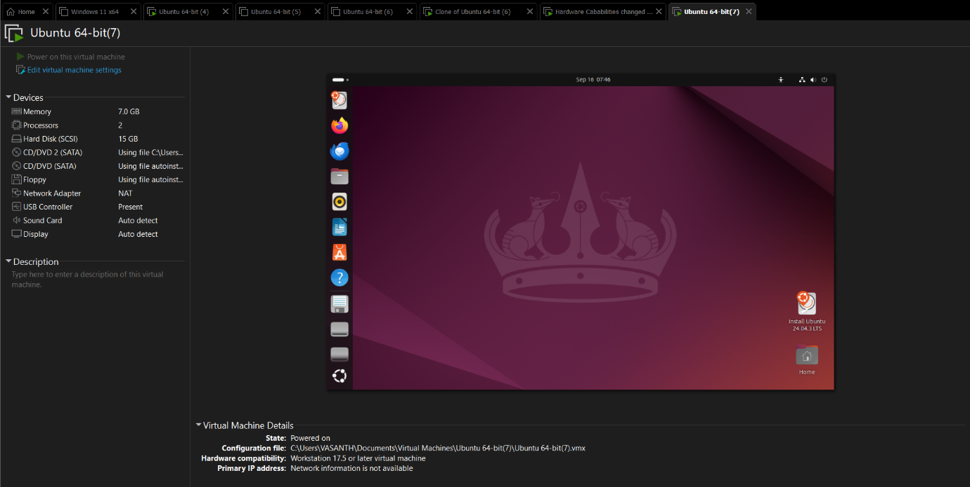

**Result:**

Virtualization was successfully demonstrated by installing VMware Workstation (a Type-2 hypervisor), creating a Virtual Machine, and installing/configuring a host operating system (Windows/Linux).